ERD and Relation Schema for Database Project
Submitted By: Omar Nadeem Siddique – L1F21BSCS0427
Submitted To: Sir Usama Pervaiz
Section: D-13
2023
ERD for Database of Judicial System of Pakistan
The following is the ERD:
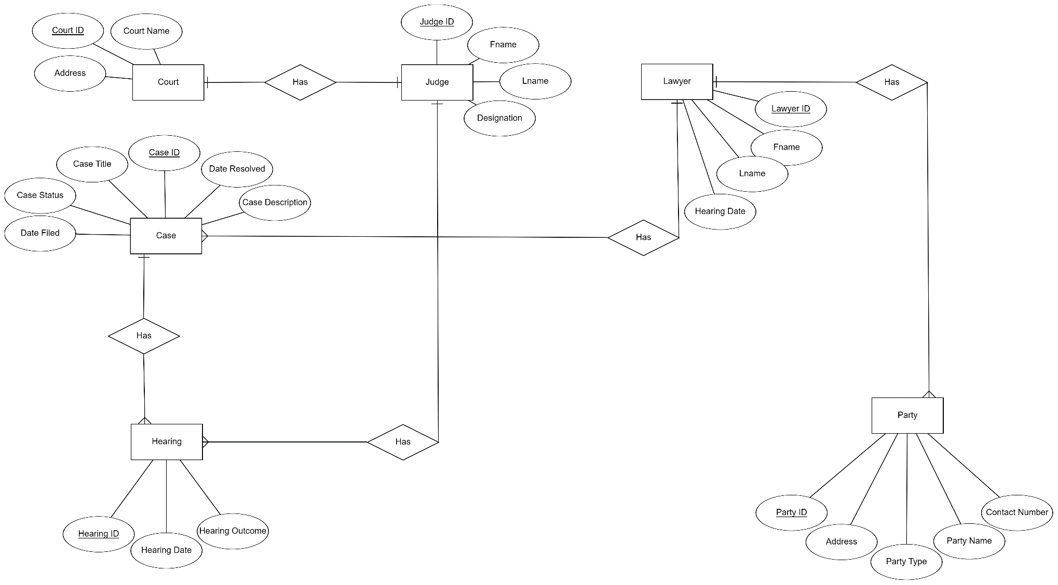

Relation Schema for Database of Judicial System of Pakistan
The following is the Relation Schema:
